## Diagonal Difference

Write a program that finds the **difference between** the **sums** of the **square matrix diagonals** (absolute value).

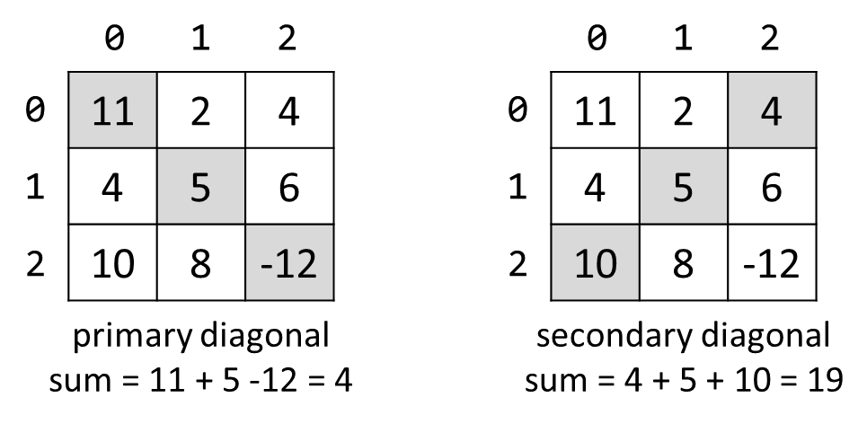

On the **first line**, you will receive an integer **N** - the size of a square matrix. The next N **lines** holds the values for **each column** - N numbers separated by a single space. Print **the absolute** difference between **the sums** of the primary and the secondary diagonal.